PAC MEETING via Zoom
June 10th 2020
- Call to order.
  - Meeting called to order at 7:05 pm
  - Attendance: Nancy Maxfield, Cody Clements, Natalie Samis, Lisa Jung, Kim Schultz, Geilan Carnell, Theresa Bourdon and Sarah Kurjata
- Principal’s report
Nancy and Cody gave insight to the principals’ report:
- Thanks to PAC & Families for their support

- Teachers - Balance online & onsite - job well done

- Staffing & Divisions
  - 14 divisions
  - Estimated numbers - 315 students
  - Staff leaving - Kim Koop, Nadine Stirling, & Jeanne Eyre
  - Staff coming - Wanda Forster - 0.6 ELL teacher/LA

- Grade 6 Farewell
  - Site based, last week, students only (~ 1-2:30 pm); a virtual gr 6. Farewell possible.
  - PAC & School combined purchase hoodies
  - School - lunch ordered - Subway

- September Start-up - as per usual, students start in class on first day back with new teacher. Wait for direction from PHO on density.

- Playground
  - School Board - new process
  - Ideas
    - https://docs.google.com/document/d/109Lm_0Mopr5VbH3aRrcAv5l9JkUtAwnnVm3OSOCG2EQ/edit
  - Timeline - Grant in the Fall
    - Invite Chad Cushway

Notes:
- No Laker news in June. Maintenance is not PAC responsibility. Playground improvements will be broken into manageable chunks. Mr. C to get quotes and/ or costs for frisbee… hoops… nets. Disc golf game.

- Idea of Exercise equipment.
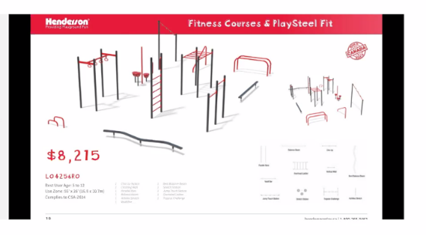
3.Review and Adopt the minutes from May 20th executive Meeting.
  - Kim motioned to adopt the minutes, Sarah to second the minutes- all in favour and carried

- Review of progress of:
  - Buddy bench design? - Kim?
    - Bench design still in progress, possible ready in the next week and then need to send design to Tanya Oftebro for final approval.
  - Apron Logo? - Natalie or Kim?
Logo colors: Blue stitching for all of the logo except white for the word “PAC”.

- Treasurer Report:
  - review and motion the budget – restricted funds amount.
- Geilan motioned to send to Andy Ackerman info in order start the grant applications, Natalie to second based on option one from “Green Root”; and to continue seeking options for playground structures. Once procedures and approval from the SD 60 completed, then can proceed with purchasing a playground structure. all in favour and carried.
- Kim motioned to spend a Max of $2200.00 for the “golf disc, frisbee type playground equipment”. Theresa to second. -all in favour and carried.
- Theresa motioned to transfer monies from general account to have only $25,500 (1.5 yr of operating costs of approx. $17,000) at the end of this fiscal year; the remainder of funds post the remaining expenses accounted for from 2019/2020 budget to be transferred into the restricted funds account for playground project. Natalie second the motion. –All in favour and carried.
- Lisa to send an email to NPSCU to have “signing” updates (removal of Lynette) and to request an account to be set up for fundraising. Natalie motioned to have another account to be set up for fundraising, Kim seconded the motion- all in favour and carried.

- Fundraiser Report.
  - Dunvegan Report.
- $795.16 profit from the Dunvegan fundraiser. Cost $3400.00. $ 38.00 increase from last year.
  - Over all changes for fundraiser 2020/2021 Calendar yr.- the up coming or first fundraiser for 2020/2021.
- ? poll in September of fundraisers.
- Thoughts of dropping Vesey; Offering Canadian Grind instead of Easter Purdy’s fundraiser.

- Playground discussion.
- Idea of the exercise equipment clarified by maybe feasible to purchase without use of restricted funds for the playground structure.
- Lisa to email Nancy the current option from Green Root- Thanks to Frances Palfy with coordinating the quote from Green Root.
- Any other business.
- PAC funded events to be posted on the fb page at the end of the school year.
- Next meeting.
- Sept 9th.2020 at 7:00 p.m. via zoom or library depending on COVID-19 protocol as directed by CL administration at the beginning of the 2020/2021 school year.
- Adjourn the meeting.
- Meeting adjourned at 0900.

